
Evidence Of The Monitoring And Measurement Of Information Security

1. Introduction
1.1 Purpose
This document outlines the processes and methods used by ABC-FinTech to monitor and measure the performance and effectiveness of its Information Security Management System (ISMS). It describes what is monitored, how it is monitored, and who is responsible for evaluating and analyzing the results, in alignment with ISO 27001:2022 standards.
1.2 Scope
This document applies to all relevant information security processes, controls, and personnel within ABC-FinTech. The monitoring and measurement activities focus on ensuring the continuous effectiveness of the ISMS and the achievement of information security objectives.

2. Monitoring and Measurement of Information Security
2.1 What Needs to Be Monitored and Measured
ABC-FinTech has identified the following information security processes, controls, and metrics for monitoring and measurement:
Monitoring Area | Objective | Key Metrics
Incident Response Performance | Measure response time and effectiveness in resolving security incidents. | Number of incidents, response time, severity
Data Encryption Compliance | Ensure that all sensitive data is encrypted at rest and in transit. | Percentage of data encrypted, encryption audits
Access Control Compliance | Ensure proper access control is in place for critical systems and data. | Number of access violations, unauthorized access
Vulnerability Management | Identify and remediate vulnerabilities in IT infrastructure. | Number of vulnerabilities identified and resolved, remediation time
Vendor Risk Management | Monitor and manage risks associated with third-party vendors. | Percentage of vendors compliant with security requirements, audit results
User Security Awareness | Assess the effectiveness of security awareness training programs. | Employee participation, test scores, phishing simulation results
2.2 Methods for Monitoring and Measurement
The following methods are used to ensure accurate monitoring, measurement, and evaluation of the ISMS:
Monitoring Area | Method for Monitoring | Measurement Tools
Incident Response Performance | Incident tracking and analysis | Incident response logs, ticketing system
Data Encryption Compliance | Encryption audits and compliance checks | Encryption audit tools, log analysis
Access Control Compliance | Regular access reviews, monitoring of access control logs | Access control logs, IAM software
Vulnerability Management | Automated vulnerability scans, manual penetration testing | Vulnerability scanning tools, pen-testing reports
Vendor Risk Management | Regular vendor security audits and assessments | Vendor risk management platform
User Security Awareness | Phishing simulations, post-training assessments | Phishing test platform, survey tools

2.3 When Monitoring and Measurement Shall Be Performed
Monitoring Area | Frequency of Monitoring
Incident Response Performance | Monthly, with real-time monitoring for critical incidents
Data Encryption Compliance | Quarterly audits
Access Control Compliance | Quarterly access reviews
Vulnerability Management | Monthly scans, annual penetration tests
Vendor Risk Management | Bi-annual audits, continuous monitoring
User Security Awareness | Quarterly phishing simulations, post-training evaluations

2.4 Who Shall Monitor and Measure
The following personnel and teams are responsible for monitoring and measuring the performance of the ISMS:
Monitoring Area | Responsible Party
Incident Response Performance | SOC (Security Operations Center) Team
Data Encryption Compliance | Data Protection Officer (DPO), IT Security Team
Access Control Compliance | IT Security Team, Access Control Administrators
Vulnerability Management | IT Security Team
Vendor Risk Management | Vendor Management Lead
User Security Awareness | HR, IT Security Team

2.5 When Results Shall Be Analyzed and Evaluated
Monitoring Area | When Results Are Analyzed
Incident Response Performance | Monthly, with real-time analysis for critical incidents
Data Encryption Compliance | Quarterly report to the Information Security Steering Committee
Access Control Compliance | Quarterly analysis of access logs and user reviews
Vulnerability Management | Monthly review of vulnerability scan results, annual pen-test analysis
Vendor Risk Management | Bi-annual review of vendor compliance status
User Security Awareness | Quarterly review of phishing simulation results and training effectiveness

2.6 Who Shall Analyze and Evaluate the Results
Monitoring Area | Responsible for Analysis and Evaluation
Incident Response Performance | SOC Manager, IT Security Manager
Data Encryption Compliance | Data Protection Officer (DPO), Chief Information Security Officer (CISO)
Access Control Compliance | IT Security Manager, CISO
Vulnerability Management | IT Security Manager, CISO
Vendor Risk Management | Vendor Management Lead, Risk & Compliance Manager
User Security Awareness | HR Manager, IT Security Manager

3. Risk Management Process Diagram
The following diagram represents the Risk Management Process, which includes risk identification, treatment, monitoring, and review.

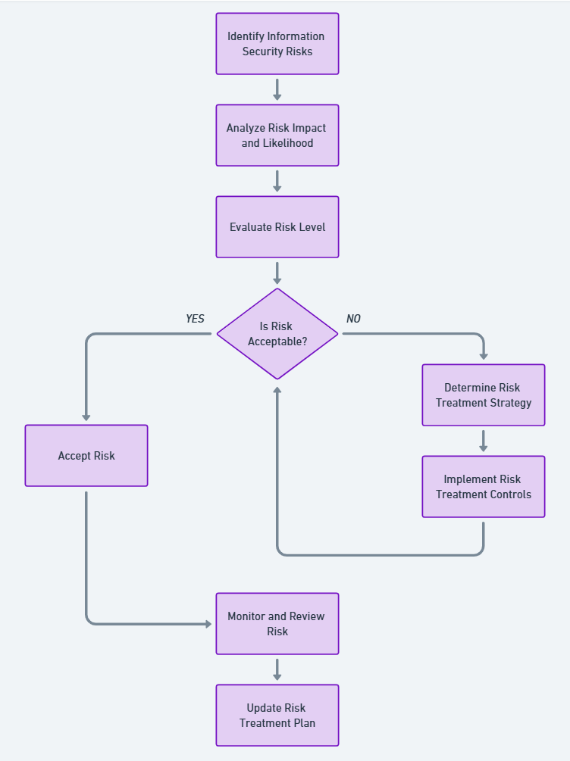

4. Evidence of Monitoring and Evaluation
4.1 Incident Response Monitoring
- Monthly Incident Reports: SOC logs and incident response performance are documented and reported to the CISO. The monthly incident reports include incident count, response times, and severity levels.
- Critical Incident Analysis: Any critical security incident undergoes real-time monitoring and immediate review, with a detailed report submitted to senior management.
4.2 Data Encryption Compliance
- Quarterly Encryption Audits: Encryption audits are performed by the DPO, and the results are presented to the Information Security Steering Committee. The audits track encryption coverage for all critical systems and identify any gaps in compliance.
4.3 Vulnerability Management
- Vulnerability Scan Results: Monthly vulnerability scans are conducted, and the results are documented. The IT Security Team analyzes scan results to identify high-risk vulnerabilities and prioritize remediation efforts.
- Annual Penetration Testing Report: The annual penetration test report is analyzed by the IT Security Manager and used to update the vulnerability management process.
4.4 User Security Awareness
- Phishing Simulation Results: The IT Security Team conducts quarterly phishing simulations and compiles the results in a report. Participation rates and test scores are analyzed to assess the effectiveness of training and adjust the awareness program accordingly.

5. Documentation and Record Retention
ABC-FinTech maintains the following documented information as evidence of monitoring and measurement activities:
- Incident Logs: SOC incident logs are retained for 3 years.
- Encryption Audit Reports: Quarterly audit reports are retained for 5 years.
- Vulnerability Management Logs: Vulnerability scan results and penetration test reports are retained for 3 years.
- Vendor Risk Assessments: Vendor audit reports are retained for the duration of the vendor contract plus 2 years.
- User Security Awareness Records: Training participation and phishing simulation results are retained for 5 years.

6. Conclusion
ABC-FinTech’s monitoring and measurement of information security processes ensure that the ISMS remains effective and aligned with the organization’s information security objectives. By using the outlined methods, personnel, and schedules, the organization continually assesses its security posture and adjusts controls as necessary to mitigate risks.

Approved by:
CEO, ABC-FinTech
Date: 22 Jan 2024

